IFC Importation from OpenStudio User Manual

# Install BIMserver 1.3.4

## Stand-alone version:

1. Download BIMserver 1.3.4 from the following Github site.

<https://github.com/opensourceBIM/BIMserver/releases/download/1.3.4-FINAL-2014-10-17/bimserver-1.3.4-FINAL-2014-10-17.jar>

2. Assuming this is your first installation, create a new folder in your system, e.g. C:\BIMserver **Note**: avoid creating BIMserver subfolder under C:\Program Files or C:\Program Files (x86)

3. Copy the downloaded bimserver-[version].jar file into the above folder, e.g. C:\BIMserver

4. Double-click on the bimserver-[version].jar file to execute it. You can specify the Java JDK folder if it is not in the System Path Environment Variable as default. Java 1.8 might not be well supported yet. For Java JDK 1.7 can be downloaded here. After setting the configurations, click start to start the server. http://www.oracle.com/technetwork/java/javase/downloads/jdk7-downloads-1880260.html

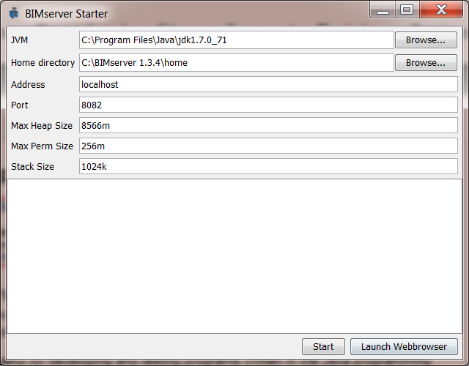

5. Wait for BIMserver to expand all the files and configure itself and until the phrase "Server started successfully" appears.

6. Click the Stop button to stop the BIMserver.

7. Download the latest OSMSerializer from the following address and copy the OSMSerializer.jar file into the plugins subfolder under the bimserver-[version] folder.

https://github.com/BIMDataHub/OsmSerializer/releases

8. Click the Start button to restart BIMserver. Once the BIMserver has restarted, click Launch Browser.

9. Setup the BIMserver for the first time by clicking the “the admin page” in the browser.

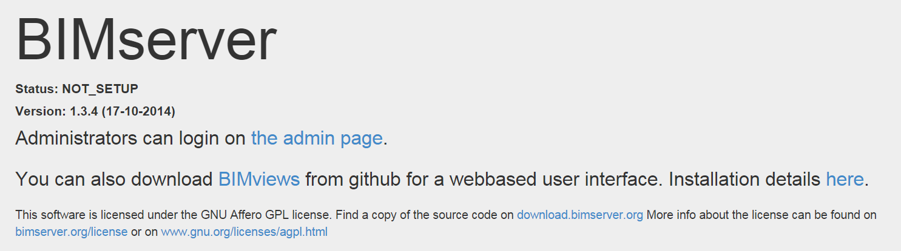

10. Enter the Administrator username and password and click Setup.

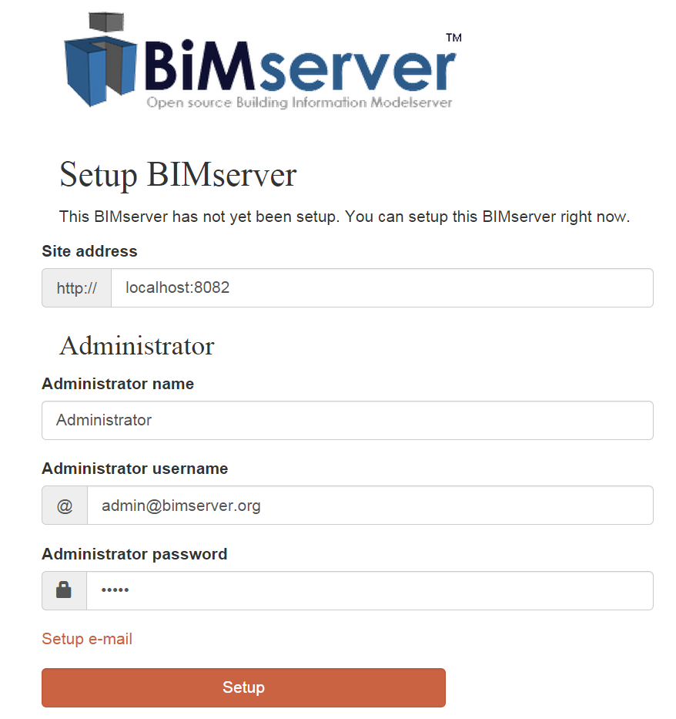

11. The BIMserver is now correctly setup and running. You can close the browser and continue to use OpenStudio to import IFC file.

## Server Version

You can download the .war version of the BIMserver here and host it with TOMCAT on a unix server.

<https://github.com/opensourceBIM/BIMserver/releases/download/1.3.4-FINAL-2014-10-17/bimserver-1.3.4-FINAL-2014-10-17.war>

Please refer to the BIMserver site on Github for more assistance.

<https://github.com/opensourceBIM/BIMserver/wiki>

# Using the Import IFC Utility on OpenStudio

## Launch import IFC utility.

1. Click File -> Import -> IFC button.

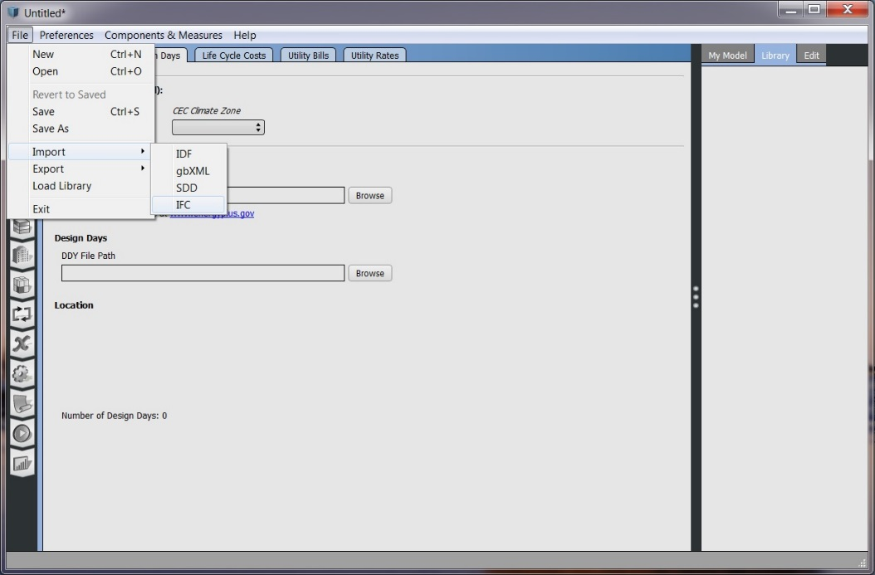

2. The first time running the import IFC utility in OpenStudio, you will need to specify the BIMserver settings information. Please enter the BIMserver Address, Port, Username and Password for the BIMserver and click Okay.

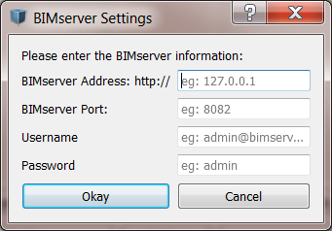

3. You will see the main window of IFC Importation as follows. The left part will list all BIM projects hosted on BIMserver. The right part will display a list of IFC revisions of a project.

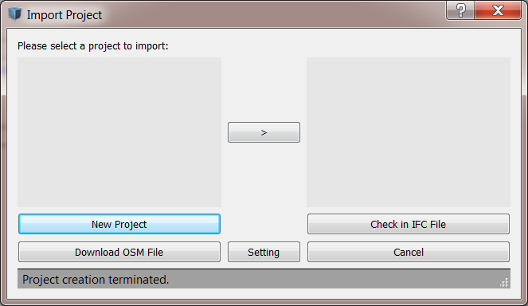

## Create a new Project

1. Create a new project by clicking the New Project Button and specify the name for the project e.g. “Test”.

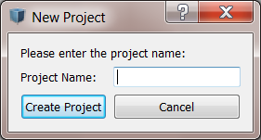

2. You will see the newly created project on the left. It contains Project ID on the BIMserver and the Project Name separated by colon.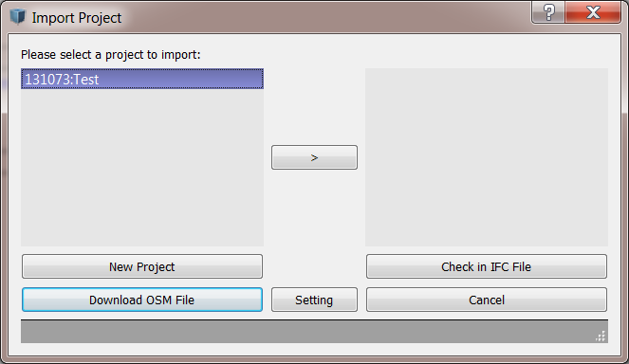

3. Click the “>” button to view the current IFC files hosted on BIMserver. It will not display anything for now since we have not check in the IFC file yet, which we will do it now.

## Check in IFC File

1. After selecting a project and clicked “>” button, click the Check in IFC File button and select an IFC file to upload it to BIMserver.

2. Now you can click the “>” button again to refresh the IFC revision list. Select the newly added file. It displays the IFC Revision ID and the time when the IFC file is uploaded, separated by colon.

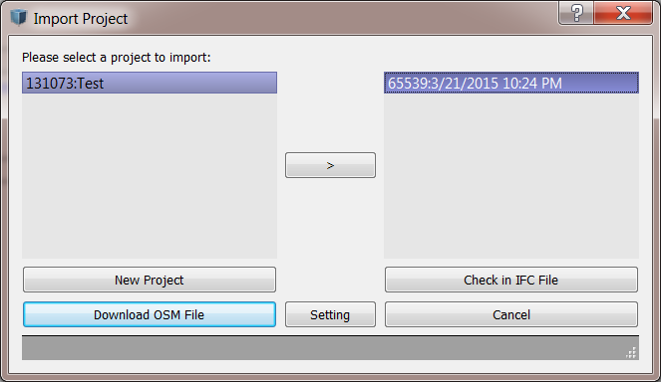

## Download OSM File

1. Click the Download OSM File button to start importing this IFC file into OpenStudio. It will ask you to save your current Open Studio model and restart the application with the newly imported model.

## Change the BIMserver Settings

If you want to change the BIMserver Settings, please simply click the Setting button and type in the new settings. It will automatically access to the new BIMserver after you click Okay.

# Scope of our current IFC importation Utility

## Goals of our IFC importation Utility

We provide an IFC to OSM transformation utility, using BIMserver as a middle-ware. Our goal is to assist energy simulation modelers to import the building geometry from IFC. The current effort requires energy simulation modelers to create the building geometry from scratch. Our current utility can partially automate this process by importing important building elements into OpenStudio from IFC. We will make and effort try to fully automate this process in the future.

## Supported IFC elements

1. Spaces will be transformed as OSM Spaces.

2. Straight and non-curved Walls are supported. It will be transformed into OSM Surface. The outside boundary condition object in OSM are also translated.

3. Ceilings and Floors will be transformed into OSM Surface.

4. Doors and Windows will be transformed into OSM Subsurface. The relationship to the corresponding Walls will be preserved.

## IFC elements under development

1. Sloped Wall and Roofs (Currently, the sloped walls cannot be transformed correctly. We are solving this problem now but follow the steps in 3.3 to modify your model)

2. The outside boundary condition object of Ceilings, floors, doors and windows

3. Curtain Walls

## What to do if you have some elements being transformed incorrectly or not transformed

1. You can save the imported OSM model in OpenStudio by clicking File -> Save As in the menu.

2. Use SketchUp with OpenStudio plugin to import the above OSM file by clicking Plugins->OpenStudio->Import->Import OpenStudio Model.

3. Modify the building geometry in SketchUp. For more information, please refer to the following tutorial.

http://nrel.github.io/OpenStudio-user-documentation/getting_started/getting_started/#installation-instructions